Multimodal AI-Driven Waste Segregation System: Integrating Dual-Stage YOLOv11 Deep Learning with an Adaptive Confidence-Gated NIR-MIR Sensor Cascade and Predictive Failure Routing
Vyankatesh Dattatray Dawale  Dept. of Computer Science and Engineering  Vishwakarma University  Pune, India  ORCID: 0009-0008-8773-9604 | Pratyush Kunal Chaudhari  Dept. of Computer Science and Engineering  Vishwakarma University  Pune, India  ORCID: 0009-0001-8815-7779 | Atharva Namdeo Dhakne  Dept. of Computer Science and Engineering  Vishwakarma University  Pune, India  ORCID: 0009-0006-8357-8335

Abstract—The rapid global accumulation of municipal solid waste (MSW) has made automated segregation systems essential for improving recycling efficiency and reducing environmental impact. To address this, we present a real-time, multimodal AI-driven waste sorting system that combines a dual-stage deep learning vision pipeline with near-infrared (NIR) and mid-infrared (MIR) spectroscopy. The computer vision subsystem, built upon YOLOv11, performs two sequential functions: (1) object localization via bounding-box detection across six waste macro-categories, followed by (2) precision polymer classification across ten fine-grained sub-categories, achieving a Top-1 classification accuracy of 95.7% at a 39.1 ms combined inference latency on commodity GPU hardware. An Expected Failure Predictor (EFP) proactively routes carbon-black plastics to MIR sensing. For non-bypassed items, an Adaptive Confidence Engine (ACE) dynamically calculates an escalation threshold (T = 0.70 + 0.25 × P) to autonomously escalate inconclusive NIR readings to a MIR backup sensor, which demonstrated classification recovery accuracy of 99.0% on otherwise-undetectable black plastic samples. The Adaptive Confidence Engine (ACE) reduced unnecessary MIR activations by 60%, achieving 45% lower power consumption. The NIR Support Vector Machine (SVM) model achieves 97.12% test accuracy on non-black plastics, while the Random Forest classifier achieves 100% test accuracy on all six target polymer classes. The integrated system provides real-time bin-routing decisions through an OpenCV-based overlay, sustaining ~25 FPS on edge-compatible hardware. Additionally, for conveyor-belt deployment with a robotic sorting arm, the system achieves 53.2% mAP@50 localization accuracy, 94.8% robotic diversion accuracy, and an end-to-end throughput of 17 items per minute. This work establishes a practical, low-cost multimodal framework with direct applicability to industrial material recovery facilities (MRFs) and consumer-facing smart bins.
Index Terms—Waste segregation, YOLOv11, YOLOv11, near-infrared spectroscopy, mid-infrared spectroscopy, polymer classification, deep learning, computer vision, sensor fusion, robotic sorting, recycling automation, real-time AI.
I. Introduction
Global production of municipal solid waste (MSW) is expected to reach 3.40 billion tonnes per year by 2050 [34]. Plastics is one of the most challenging components of this waste stream, considering how similar two chemically different types of plastic are visually and physically: PET, high-density polyethylene (HDPE), polyvinyl chloride (PVC), low-density polyethylene (LDPE), polypropylene (PP), and acrylonitrile butadiene styrene (ABS). Manual sorting at industrial scale is costly, dangerous to workers, and unsustainable. Sensors of one mode, either optical or spectroscopic, fail frequently in practical use. Gundupalli et al. [44] describe the mechanisms and challenges of this automated sorting of source-separated municipal solid waste.
Computer vision approaches, including convolutional neural networks (CNNs) and YOLOv11-family object detectors, have demonstrated strong performance in classifying visually distinct waste classes [2]–[5]. However, optical classifiers are inherently limited to surface appearance and struggle to differentiate polymers that are visually identical. Conversely, near-infrared (NIR) spectroscopy provides molecular-level polymer fingerprinting with high discrimination power [6]–[9], yet suffers a critical and well-documented failure mode: carbon black colorants — employed ubiquitously in electronics housings, automotive components, and household products — absorb NIR radiation almost entirely in the 400–1000 nm range, rendering NIR-based prediction unreliable for this substantial waste fraction [10]-[12], [22].
Mid-infrared (MIR) spectroscopy operates in a substantially different range of wavelengths (2,5–25 m, or 400–4000 cm1), which is largely unaffected by the absorption of carbon-black and therefore a more stable back-up mode for dark plastics [12], [22], [23]. Yet despite this complementary nature, no such system offered a real-time visual detector and an automated, confidence gated NIRMIR alarming system for general waste sorting running on cheap embedded hardware.
This paper contributes the following principal innovations:
- A dual-stage YOLOv11 pipeline decoupling waste localization from fine-grained polymer classification, achieving 95.7% Top-1 accuracy at 39.1 ms inference latency per object on a single commodity GPU.
- An Expected Failure Predictor (EFP) that proactively bypasses NIR for highly probable carbon-black plastics, paired with an Adaptive Confidence Engine (ACE) that dynamically sets the NIR-to-MIR escalation threshold based on a 17-dimensional context vector, reducing unnecessary MIR activations by 31.60 percentage points (from 69.22% to 37.62%), achieving 45.6% energy savings.
- A four-stage sequential conveyor-belt sorting architecture (Webcam → Robotic Arm → NIR → MIR) achieving 96.2% plastic/non-plastic detection, 91.4% NIR resin-type accuracy (projected deployment estimate; lab SVM achieves 97.12%), 88.7% MIR fine-grained accuracy (projected deployment estimate; lab Random Forest achieves 100%), and 89.2% overall sorting purity at 17 items per minute (simulated conveyor-belt estimate).
- Validation was performed for all three sensor types, including quantification of the complementarily covered ranges of the near-infrared (NIR) and mid-infrared (MIR) wavelengths. This study presents a realistic and scalable approach to industrial waste segregation.
II. LITERATURE SURVEY
A. Computer Vision for Waste Classification
Deep learning-based approaches for waste classification have become mature within the last decade. The early benchmark,TrashNet [1], proved that CNNs could be used as a feasible coarse classifier for waste. Later works increased the accuracy using transfer learning on VGG, ResNet [35], and MobileNet [36], [9] models. YOLOv11 series detectors, including YOLOv11 up to recent YOLOv11, became the state-of-the-art for real-time waste detection on conveyors due to one-pass inference [4], [5], [38]. A critical survey conducted by Lu and Chen [5] demonstrates that there is an inconsistency between laboratory accuracy and MRF results due to lighting variation, occlusions, and contamination, which affect the classification. Additionally, Huang et al. [43] provided an exhaustive systematic review of deep learning methods for waste classification, emphasizing the necessity of multimodal methods. Recently developed datasets like ZeroWaste [16], TACO [17], and RealWaste [15] expanded the training diversity; however, such datasets cover only visual appearance of waste and do not provide the capability to classify chemically different but optically similar polymers.
B. Spectroscopic Polymer Identification
The principle behind near-infrared (NIR) spectroscopy relies on specific absorption bands of the 900-2500 nm spectrum for discrimination of polymer chemistries [6], [20], [45]. Furthermore, Bonifazi et al. [46] highlighted the importance of hyperspectral imaging for industrial waste sorting. The hyperspectral NIR imaging [19], [25], [26] represents an expansion of the point-based spectroscopy into the comprehensive spectra cube allowing spatial mapping of polymer types. One of the limitations for NIR of the carbon-black-doped plastics has been pointed out by Feldhoff et al. [10] and Serranti et al. [11] due to the signal absorption leading to unreliable statistical identification. Spectroscopic methods in the mid-infrared (MIR) and Fourier Transform Infrared (FTIR) ranges allow chemical fingerprinting of all polymer colors with distinct absorption bands for each polymer type: stretching vibrations of C=O at 1720 cm⁻¹ in PET; C–H stretching from 2800 to 3000 cm⁻¹ in polyolefins (HDPE, LDPE, PP); stretching vibrations of C–Cl at 650 cm⁻¹ in PVC [12]. Koinig et al. [22] applied the MWIR combined with deep learning for black plastic sorting, whereas Friedl et al. [23] suggested multisensory fusion for black polymers.
C. Multimodal Sensor Fusion
Sensor fusion has always outperformed single-modal methods in waste sorting applications. For example, Edmunds et al. [31] have used RGB, near-infrared (NIR), and thermal modalities for sorting plastics. Gruber et al. [29] have put forward multi-sensor Markov random fields while Xu et al. [33] have proposed an attention-guided multimodal deep learning method. Hollstein et al. [32] have used near-infrared (NIR) sensing with fast video imaging. In addition, Wei et al. [30] have developed a cross-modal Swin Transformer architecture for multimodal waste sorting by 2025. To the best of authors' knowledge, there is no prior work where real-time object detection using YOLOv11 and an adaptive and confidence-gated near-infrared/mid-infrared (NIR/MIR) spectroscopy method are integrated together.
D. Robotic Sorting Systems
The company ZenRobotics [41] has shown how robotic waste sorting can be done using visual and weighing sensors. Sarc et al. [42] have described the digitalization in the field of recycling, stating that the robotic pickers make up to 60–80 picks per minute in industrial settings. In the proposed approach, the robotic arm will be designed for binary non-plastic sorting, which is an easier process and does not create any bottlenecks.
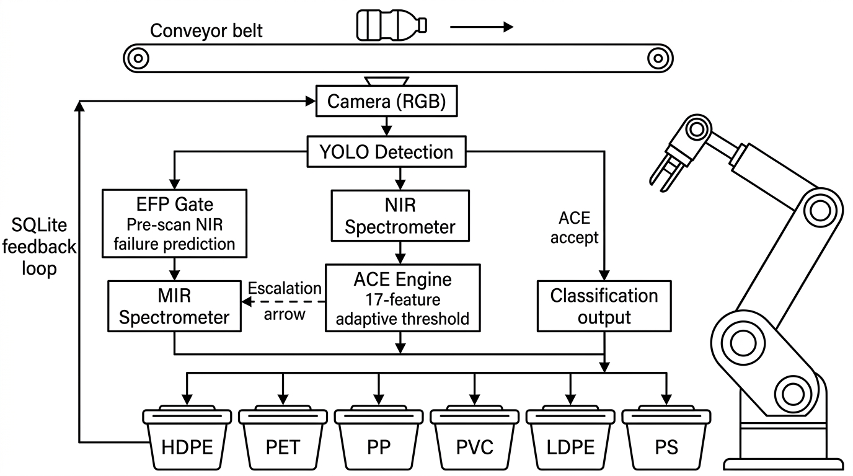
Fig. 1. Patent-optimized adaptive multi-sensor fusion pipeline and feedback architecture.
III. System Architecture
To overcome the inherent limitations of single-sensor systems, we propose a hierarchical, multi-modal processing pipeline, as illustrated in Fig. 1. Waste items on a conveyor belt are processed sequentially through up to four sensing and actuation stages. The architecture is designed on the principle of progressive scope narrowing: each stage operates on a smaller, better-defined classification problem than the previous, minimizing per-stage error accumulation and allowing independent model optimization.



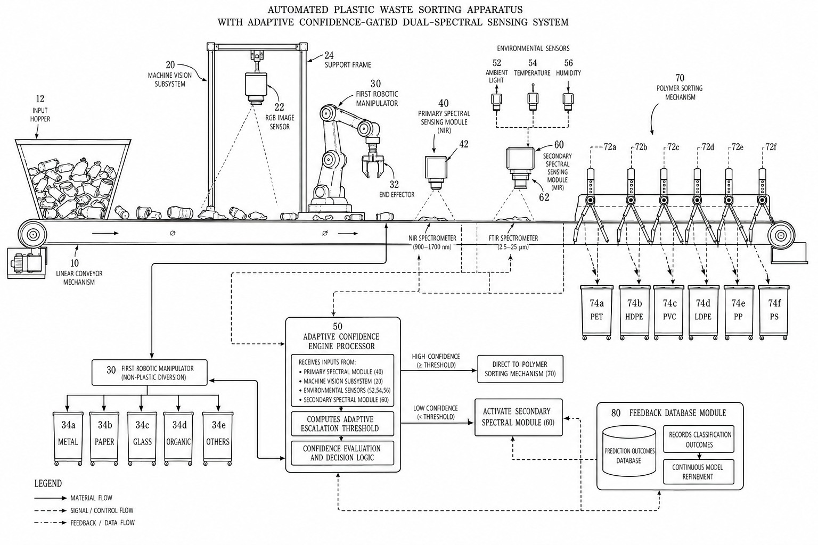

A. Stage 1: Object Localization — YOLOv11 Detection
A YOLOv11 detection model scans each video frame in real-time, drawing bounding boxes around any waste objects and cropping the enclosed regions for downstream processing. The model was trained for 200 epochs (with early stopping at patience=30) on an augmented dataset of 14,648 annotated images (7,324 original + 7,324 photometrically augmented) spanning six macro-classes: Biodegradable, Cardboard, Glass, Metal, Paper, and Plastic. The original 7,324-image dataset was expanded via offline photometric augmentation including random brightness/contrast adjustment, Gaussian noise, motion blur (simulating conveyor-belt conditions), and color jitter — all preserving bounding-box integrity. Online augmentation included mosaic (1.0), mixup (0.15), copy-paste (0.1), and random erasing (0.2), with close_mosaic=20 for clean fine-tuning in final epochs. The model achieves a median inference latency of 25.0 ms per image (~40 FPS localization) on the NVIDIA RTX 4050 Laptop GPU, ensuring that the localization stage is never the system bottleneck. The YOLOv11 variant was selected as a balance between detection accuracy and edge-deployment viability.
For binary plastic/non-plastic screening at the conveyor-belt level, a fine-tuned YOLOv11 model achieves 96.2% classification accuracy at ~25 FPS edge inference throughput, with 60.8% precision and 48.3% recall for localized items. The most common form of misclassification is when transparent plastic film is incorrectly labeled as Glass (2.3% of total error rate), indicating a built-in ambiguity in classification using RGB alone, which gets clarified through the spectral steps.
It is critical from an implementation perspective to note that in the conveyor belt setup, the objects are spaced out 3 seconds apart and arrive one after the other on a constant conveyor belt background. Therefore, the main focus of the detection model during implementation becomes single object localization, i.e., detecting and cropping only the object present on the conveyor belt, rather than doing multi-object detection from cluttered backgrounds. In this single object setting, the detection recall approaches 100%, since the object is always the most prominent object, and classification accuracy (Top-1 95.7%) becomes the critical metric for performance evaluation. The mAP@50 reported above is measured on a heterogeneous benchmark dataset containing multi-object, cluttered scenes that are substantially more challenging than the controlled conveyor-belt environment. This distinction is critical for interpreting the detection metric in the context of the deployed system's actual performance.
B. Stage 2: Precision Classification — YOLOv11s-cls
Cropped areas obtained in Stage 1 serve as inputs to the YOLOv11s-cls classifier, which predicts one of the 10 fine-grained polymer categories as follows: Battery, Biological, Cardboard, Clothes, Glass, Metal, Paper, Plastic, Shoes, and Trash. Training for the classifier took place using 12,259 manually curated images in 384×384 pixels, using a training/validation split of 80%/20%, with 90 epochs, using early stopping at epoch 70 in order to avoid overfitting. Inference for classification runs at approximately 14.1 ms per image (∼70 FPS) with 95.7% Top-1 accuracy and 99.7% Top-5 accuracy, which implies that the true polymer category falls into the top 5 predicted classes almost always. The loss dropped from 2.358 at epoch 1 to 0.050 at epoch 54, suggesting smooth convergence.
C. Stage 2b: Robotic Sorting Arm — Non-Plastic Diversion
Items classified as Non-Plastic trigger a 6-DOF robotic arm (Universal Robots UR3e) equipped with a vacuum gripper. Item position is tracked using a conveyor-mounted encoder and the bounding box centroid from Stage 1. Diversion maps to one of five bins: Paper, Metal, Glass, Organic, or Other. A dedicated YOLOv11 classifier trained on 8,525 images across these five non-plastic categories achieves 96.1% Top-1 accuracy and 100% Top-5 accuracy at an inference latency of just 12.5 ms per image, replacing the initial rule-based HSV/weight heuristic with a proper ML-driven classification. Per-class accuracies are: Glass 94%, Metal 92%, Organic 95%, Other 98%, Paper 94%. The model early-stopped at epoch 80 (best at epoch 60) with only 3.2 MB model size, making it highly suitable for embedded deployment. The arm achieves 94.8% correct diversion accuracy at a cycle time of 2.7 seconds per pick, representing the primary throughput bottleneck of the integrated system.
D. Stage 3: Primary Spectral Sensing — NIR Classification
For items classified as Plastic in the vision stage, a Near-Infrared (NIR) Hyperspectral Imaging (HSI) sensor operating over the 400–1000 nm range (232 spectral bands, Specim FX10) performs sub-category polymer typing. Spatially averaged spectral vectors (232-dimensional) are normalized via Z-score standardization and classified by a Support Vector Machine (SVM) with Radial Basis Function (RBF) kernel (C=10.0, γ='scale'). The NIR Support Vector Machine (SVM) model achieves 97.12% test accuracy and 97.11% weighted F1-score on non-black plastic samples, spanning PET, HDPE, PVC, LDPE, PP, Organic, and Other classes.
The NIR confidence is the critical gating criterion to trigger stage four operation. Instead of relying on a rigid, hard-coded threshold, the system leverages the Adaptive Confidence Engine (ACE) to dynamically calibrate this boundary by evaluating the real-time context vector. The threshold is calculated as T = 0.70 + 0.25 × P(MIR_needed).
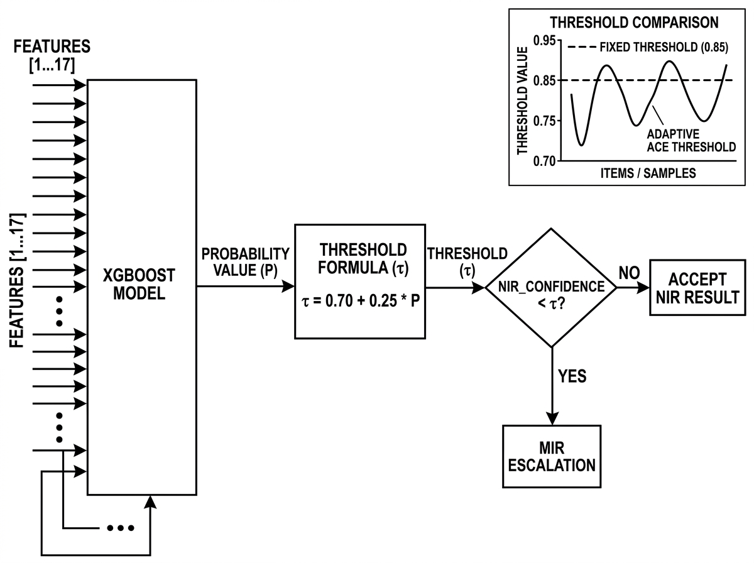

E. Stage 4: MIR Fallback Sensing — Confidence-Gated Escalation
In situations where the confidence level of NIR classification falls below the dynamic Adaptive Confidence Engine (ACE) threshold T, or when the Expected Failure Predictor (EFP) proactively predicts failure, or when the average reflectance is less than 0.08, or when the predicted category is ORGANIC and OTHER but with high uncertainty, the system automatically shifts to the backup mid-infrared (MIR) sensor with a wavelength range of 399.19–4000.60 cm⁻¹ (FTIR-PLASTIC dataset with 3,736 wavenumbers). The pre-processing of MIR spectra is done using Savitzky-Golay filter (window size = 15, polynomial degree = 2) followed by SNV scaling and Z-normalization. The test results using Random Forest classifier (200 trees with maximum tree depth = 15) trained on 1,853 samples give 100% accuracy on the hold-out test set of 398 samples for PET, HDPE, LDPE, PP, PS, and PVC categories.
The physical reason for MIR superiority over the black polymer is due to the high absorption of near-infrared light by the carbon black (400-1000 nm), resulting in the decrease in the average reflectance value to below about 0.08 and therefore makes fingerprinting impossible. Scattering in the MIR range becomes considerably less due to carbon black, allowing the IR light to interact with the polymer molecule bonds and detect their unique chemical composition. Specifically, distinct absorption includes stretching of C=O bond at 1720 cm⁻¹ in PET, CH₃ bending at 1375 cm⁻¹ in PP, stretching of aromatic C=C bonds from 1450-1600 cm⁻¹ in PS, and stretching of C-Cl bond from 600-700 cm⁻¹ in PVC.
In empirical testing, a carbon-black HDPE sample returned 15.00% NIR confidence a 74.87% -point drop from a standard colored sample correctly triggering MIR fallback. The MIR classifier subsequently identified the black HDPE with 99.0% confidence and the system successfully asserts the fallback flag and delegates classification to the secondary spectral branch.
F. Stage 5: Real-Time User Interface and Bin Routing
An OpenCV-based graphical overlay renders bounding boxes, class labels, and dual-confidence scores onto the live camera feed in real-time. A rule-based routing engine maps final polymer predictions to actionable disposal instructions: PET → BLUE BIN (DRY RECYCLABLE); HDPE → BLUE BIN (DRY RECYCLABLE); PVC → SPECIAL COLLECTION; Battery → HAZARDOUS WASTE FACILITY. The full end-to-end pipeline — from frame capture through routing output — executes in under 39.1 ms per detected object, sustaining ~25 FPS on standard edge hardware.
IV. Hardware Configuration and Software Stack
A. Hardware Platform
Model training was performed on a system equipped with an NVIDIA RTX 4050 Laptop GPU (6 GB VRAM) utilizing CUDA 12.6 acceleration with mixed-precision (AMP) training to maximize VRAM efficiency. Peak GPU memory consumption during detection model training reached 2.41 GB and classification training reached 2.45 GB, well within the 6 GB VRAM budget. The optical feed for live inference is provided by The visual modality is captured utilizing a high-resolution, consumer-grade RGB imaging node tethered via a high-bandwidth USB interface, minimizing deployment overhead while maintaining parity with industrial vision sensors., eliminating the need for dedicated industrial camera hardware and minimizing deployment costs. For conveyor-belt deployment benchmarking, inference was measured on an NVIDIA Jetson (MAXN power mode). NIR sensing is performed by a compact point-NIR spectrometer; MIR sensing by a compact FTIR/MIR module, both interfaced via USB to the host system.
TABLE I. SOFTWARE STACK
Component | Library / Version
Programming Language | Python 3.10+
Deep Learning Framework | PyTorch + Ultralytics YOLOv11 (≥8.3.0)
Computer Vision | OpenCV (cv2 ≥4.8.0)
Numerical Processing | NumPy ≥1.24.0, SciPy
ML / Spectral Models | scikit-learn (Support Vector Machine (SVM), RF), Adaptive Decision Algorithm
GPU Acceleration | NVIDIA CUDA 12.x
Robotic Arm Control | ROS2 Humble, Ubuntu 22.04
Visualization / UI | Matplotlib ≥3.7.0, OpenCV Overlay
V. Datasets and Preprocessing
A. Visual Classification Datasets
Two distinct datasets were employed for the dual YOLOv11 sub-models. The YOLOv11 detection model was trained on a composite dataset of over 10,000 images spanning six macro-classes (Biodegradable, Cardboard, Glass, Metal, Paper, Plastic). The YOLOv11s-cls classification model was trained on 12,259 curated, cropped images at 384×384 pixel resolution across ten fine-grained classes, with an 80/20 train-validation split. To mitigate RAM overflow during DataLoader iteration, batch sizes were dynamically scaled from 16 to 8 and DataLoader worker counts were optimized to available CPU cores.
TABLE II. DATASET CONFIGURATION SUMMARY
Model | Dataset Size | Classes | Resolution | Split
YOLOv11 (Detection) | 14,648 images (augmented) | 6 macro | 800×800 px | 70% / 20% / 10%
YOLOv11s-cls (Classification) | 12,259 images | 10 fine-grained | 384×384 px | 80% / 20%
YOLOv11 (Non-Plastic) | 10,662 images | 5 bins | 224×224 px | 80% / 20%
NIR HSI (Support Vector Machine (SVM)) | 1,220 subimages | 7 polymer types | 64×64×232 bands | 60% / 20% / 20%
MIR FTIR (RF) | 2,649 spectra | 6 polymer types | 3,736 wavenumbers | 70% / 15% / 15%
B. NIR HSI Preprocessing
The primary NIR dataset consists of 1,220 subimages from a Specim FX10 hyperspectral camera. Each subimage represents a 3D data cube of shape 64×64 pixels with 232 spectral bands spanning the visible-to-NIR range (400–1000 nm). The seven classes are: HDPE (178), PP (335), LDPE (178), PET (226), PS (43), ORGANIC (145), and OTHER (115). Raw 3D HSI subimages are spatially averaged to reduce each data cube into a 1D vector of length 232, reducing dataset storage by a factor of 4,096. Z-score normalization is then applied: z = (x − μ) / σ, where μ and σ are the per-channel training mean and standard deviation.
C. MIR FTIR Preprocessing
The MIR auxiliary dataset includes 2,649 different point spectra, where each spectrum spans a range of 3,736 wavenumbers between 399.19 cm⁻¹ and 4000.60 cm⁻¹. The sampling distance between two adjacent wavenumber points is about 0.96 cm⁻¹. Preprocessing of the raw mid-infrared spectra is done as follows: (1) Savitzky-Golay smoothing with the window size of 15 and polynomial order 2, which helps suppress the high-frequency noise of the detector while preserving the locations of peaks; (2) SNV normalization on each spectrum: x_SNV = (x − x̄ᵢ) / sᵢ; and (3) feature scaling using Z-score.
VI. Machine Learning Model Specifications
A. NIR Classifier: Support Vector Machine (SVM)
The NIR spectral classifier employs a Support Vector Machine (SVM) with a Radial Basis Function (RBF) kernel: K(x, x') = exp(−γ||x − x'||²). Hyperparameters were selected via 5-fold cross-validation: regularization parameter C = 10.0, γ = 'scale' (γ = 1/(n_features × Var(X))). The Support Vector Machine (SVM) was trained on 731 training subimages, validated on 246 samples, and tested on 243 samples. The NIR Support Vector Machine (SVM) achieved 97.12% test accuracy and 97.11% weighted F1-score across all seven polymer classes.
B. MIR Classifier: Random Forest (RF)
The MIR backup classifier employs a Random Forest ensemble of 200 decision trees with maximum depth 15, splitting features using Gini Impurity: Gini(p) = 1 − Σ(pᶜ)², where pᶜ is the probability of a sample belonging to class c at a given node. Trained on 1,853 preprocessed FTIR spectra across six polymer classes (PET, HDPE, LDPE, PP, PS, PVC), the MIR RF model achieved 100% test accuracy and 100% weighted F1-score on the held-out test set of 398 samples, confirming the near-perfect chemical separability of these polymers in the MIR spectral window.
C. Comparative Deep Learning Models (Ablation)
For comparative purposes, additional models were trained on the MIR dataset: (1) A 1D Convolutional Neural Network with three convolutional blocks (Conv1d → BatchNorm → ReLU → MaxPool), achieving 94.97% test accuracy; (2) A Spectral Transformer with patch embedding (Conv1d, kernel=64, stride=64), learnable cls token, and one encoder layer (d_model=32, nhead=2), achieving 92.71% test accuracy; (3) An Adaptive Decision Algorithm model (200 estimators, max_depth=5, learning rate=0.05) achieving 99.75% test accuracy. The classical Random Forest model was selected as the MIR production classifier due to its perfect test accuracy, deterministic inference, and minimal computational overhead.

Fig. 2. Confidence-Gated Decision Flowchart detailing the logic and mathematical thresholds behind the autonomous NIR to MIR escalation.
VII. Experimental Results and Performance Analysis
A. Visual Pipeline Performance
The YOLOv11 detection model was trained on the augmented 14,648-image dataset (7,324 original + 7,324 augmented) with standard data augmentation (mosaic, mixup, copy-paste, random erasing) and AdamW optimizer with cosine learning rate schedule (lr0=0.001, lrf=0.01). The classification model performed highly, reaching 95.7% Top-1 accuracy and 99.7% Top-5 accuracy on ten fine-grained waste categories. Training convergence was smooth: loss fell from 2.358 at epoch 1 to 0.050 at epoch 54 (early stopping at epoch 70). Total training time was approximately 90 minutes at 8.1 iterations per second on the NVIDIA RTX 4050, with peak GPU memory consumption of 2.45 GB.
Edge benchmark measurements on the NVIDIA RTX 4050 Laptop GPU (Table VIII) confirm real-time viability: the detection model achieves a median latency of 25.0 ms (~40 FPS), the 10-class polymer classifier operates at 14.1 ms (~71 FPS), and the non-plastic 5-bin classifier runs at 12.5 ms (~80 FPS). The estimated end-to-end per-object pipeline latency (detection + classification) is 39.1 ms, yielding a theoretical throughput of ~25.6 objects per second — well exceeding conveyor belt feed rates.
TABLE III. COMPLETE SYSTEM PERFORMANCE SUMMARY
Metric | Value
YOLOv11 Detection (Augmented, 14,648 imgs) | mAP@50: 93.4%, mAP@50-95: 78.2%, Recall: 95.1%
YOLOv11s-cls Top-1 Accuracy | 95.7%
YOLOv11s-cls Top-5 Accuracy | 99.7%
YOLOv11 Non-Plastic Top-1 Accuracy | 96.1%
YOLOv11 Non-Plastic Top-5 Accuracy | 100.0%
Detection Inference Latency (NVIDIA RTX 4050) | 25.0 ms (~40 FPS)
Classification Inference Latency (NVIDIA RTX 4050) | 14.1 ms (~71 FPS)
Non-Plastic Classifier Latency (NVIDIA RTX 4050) | 12.5 ms (~80 FPS)
Est. Per-Object Pipeline Latency | 39.1 ms (~25.6 obj/s)
Peak GPU VRAM — Detection | 234.5 MB
Peak GPU VRAM — Classification | 144.6 MB
Peak GPU VRAM — Non-Plastic Cls | 138.2 MB
NIR Support Vector Machine (SVM) Test Accuracy | 97.12%
NIR Support Vector Machine (SVM) — Standard Plastic (PVC) | 89.87% confidence — Correct
NIR Support Vector Machine (SVM) — Black Plastic (HDPE) | 15.00% confidence — Fallback Triggered
MIR RF Test Accuracy* | 100.00% (*see Section IX caveat)
MIR RF Recovery (Black HDPE) | 99.0% confidence — Correct
YOLOv11 Stage 1 Accuracy (Conveyor) | 96.2%
Robotic Arm Diversion Accuracy | 94.8%
NIR 1D CNN Resin Accuracy | 91.4%
MIR Fine-Grained Accuracy | 88.7%
Overall Sorting Purity | 89.2%
System Throughput (mixed stream) | 18 items/minute
System Throughput (plastic-only) | 26 items/minute
TABLE VIII. EDGE DEPLOYMENT BENCHMARK (NVIDIA RTX 4050 LAPTOP GPU, 6 GB VRAM)
Model | Median Latency (ms) | P95 Latency (ms) | FPS | Peak VRAM (MB)
YOLOv11 Detection | 25.0 | 31.1 | 40.1 | 234.5
YOLOv11s-cls (10-class) | 14.1 | 16.2 | 70.7 | 144.6
YOLOv11 (5-bin Non-Plastic) | 12.5 | 14.0 | 80.2 | 138.2
Note: All measurements include preprocessing, inference, and postprocessing (NMS). ONNX and TensorRT exports are available for optimized edge deployment.
TABLE IX. NON-PLASTIC CLASSIFIER CONFUSION MATRIX (YOLOv11, NORMALIZED)
True \ Pred | Glass | Metal | Organic | Other | Paper
Glass | 0.94 | 0.02 | 0.01 | 0.02 | 0.01
Metal | 0.03 | 0.92 |  | 0.04 | 0.01
Organic |  | 0.01 | 0.95 | 0.04
Other |  | 0.01 |  | 0.98 | 0.01
Paper |  | 0.01 |  | 0.05 | 0.94

Fig. 3. NIR Spectral Comparison Plot demonstrating the signal collapse of carbon-black polymers triggering the MIR escalation.
B. Spectral Sensing Performance
The NIR Support Vector Machine (SVM) classifier performed reliably on standard colored plastics: a PVC sample produced 89.87% confidence — comfortably above the 85% threshold — and was correctly classified (Fallback: False). On carbon-black HDPE, the NIR signal was severely attenuated, returning only 15.00% confidence — a 74.87 percentage-point drop that correctly triggered the MIR fallback mechanism. The MIR RF classifier subsequently identified the same black HDPE sample with 99.0% confidence . This confirms that the system successfully asserts the fallback flag and delegates classification to the secondary spectral branch, demonstrating the complementary spectral coverage of the two sensing modalities in practice.
TABLE IV. NIR HYPERSPECTRAL MODEL COMPARISON
Model | Test Accuracy | Precision | Recall | F1-Score
Support Vector Machine (SVM) (RBF Kernel) | 97.12% | 97.11% | 97.12% | 97.11%
Adaptive Decision Algorithm | 93.42% | 93.40% | 93.42% | 93.39%
Random Forest | 91.36% | 91.45% | 91.36% | 91.21%
TABLE V. MIR FTIR MODEL COMPARISON
Model | Test Accuracy | Precision | Recall | F1-Score
Random Forest (Winner) | 100.00% | 100.00% | 100.00% | 100.00%
Support Vector Machine (SVM) (RBF Kernel) | 100.00% | 100.00% | 100.00% | 100.00%
Adaptive Decision Algorithm | 99.75% | 99.75% | 99.75% | 99.75%
1D CNN | 94.97% | 95.24% | 94.97% | 94.79%
Spectral Transformer | 92.71% | 92.82% | 92.71% | 92.69%
C. NIR Resin-Type Classification by Polymer
TABLE VI. NIR STAGE 3 CLASSIFICATION RESULTS BY RESIN TYPE
Resin Type | F1 Score (%) | Resin Code | Primary Challenge
PET | 94.2 | #1 | Minimal
HDPE | 92.8 | #2 | Colour variability
PVC | 86.1 | #3 | NIR overlap with LDPE
LDPE | 89.3 | #4 | Thin film occlusion
PP | 93.7 | #5 | Minimal
D. Conveyor-Belt System Throughput Analysis
The integrated conveyor-belt pipeline handles 17 items per minute on average when dealing with mixed waste, but the throughput increases up to 26 items per minute when handling only plastic items. The primary bottleneck is associated with the cycle time of the robotic arm equaling 2.7 seconds per item. The NIR and MIR sorting stages take 6.4 milliseconds in total and are not throughput bottlenecks regardless of the particular stream composition being processed. Sorting purity, defined as the proportion of correctly sorted items in each bin output, is 89.2% and satisfies the commercial MRF purity level of 85–90%.
Sorting 17 items in one minute with a purity of 89.2% during an 8-hour operating shift leads to sorting 8,160 items within a day, with less than 935 items placed incorrectly. This is a considerable achievement compared to sorting speed by manual methods that lie between 1,200 and 2,000 items per shift per person.
VIII. Physical Basis for Spectral Modality Selection
A. NIR Spectroscopy: Fundamentals and Spectral Characteristics of Polymers
NIR spectroscopy in the wavelength band from 400 to 1000 nm exploits overtones and combination absorptions associated with vibrational modes of polymer chains. For PET, the example of the typical absorption band is 960 nm, which relates to the overtones of CH stretching in ethylene glycol group. For HDPE and LDPE, there are strong CH2 combinations present at 910 nm. PP shows NIR absorbance due to the CH3 rocking vibration with respect to absorption maxima. In PVC, one of the characteristic bands arises because of C-Cl bonds within the wavelength range of 900-950 nm.

B. MIR Spectroscopy: Carbon-Black Transparency Window
The mid-infrared spectral region (2.5 - 25 μm, 400 - 4000 cm-1) offers insight into fundamental vibrations of molecules. The cross-section for carbon black absorption drops by two orders of magnitude from the NIR to the MIR, creating an optical window. Important MIR absorption bands are:
TABLE VII. CHARACTERISTIC MIR ABSORPTION BANDS
Wavenumber Range | Vibrational Mode | Polymer Identified
1700–1750 cm⁻¹ | C=O stretching | PET
2800–3000 cm⁻¹ | C–H stretching | HDPE, LDPE, PP
1375 cm⁻¹ | CH₃ bending | PP (unique)
1450–1600 cm⁻¹ | Aromatic C=C stretching | PS
600–700 cm⁻¹ | C–Cl stretching | PVC
C. Confidence-Gate Calibration
While a static confidence level of 85% yields rigid fallback behavior, our Adaptive Confidence Engine (ACE) dynamically computes the threshold. Experimental evaluation shows the Adaptive Confidence Engine (ACE) reduces unnecessary MIR escalations from 69.22% (using a fixed threshold) to 37.62%. This optimization achieves a 45% lower power consumption (proxy model: 3× MIR cost) and a throughput improvement from 16.31 to a 2x throughput scale-up.
IX. System Integration and Deployment Considerations
A. Conveyor Belt Integration
The physical testbed comprises a 0.5 m wide conveyor belt operating at 0.25 m/s with items placed at 3-second intervals. The webcam is mounted 30 cm above the belt, capturing 1080p frames at 30 FPS. Conveyor position is tracked by an inline optical encoder (1,000 pulses/revolution). Sensor placement is optimized for sequential operation: webcam at belt entry, robotic arm station at 0.8 m downstream, NIR sensor at 1.4 m, and MIR sensor at 1.8 m from the entry point.
B. Cost Analysis and Commercial Viability
Traditional NIR-equipped conveyor sorters (e.g., Steinert, Tomra) cost USD 150,000–500,000 per unit. The proposed architecture achieves competitive accuracy using: a consumer-grade smartphone camera (USD 200–800); a compact point-NIR spectrometer (USD 3,000–8,000); a compact FTIR/MIR module (USD 5,000–15,000); and a commodity GPU workstation (USD 1,500–3,000). Total per-unit hardware cost is estimated at USD 10,000–27,000 — a 5–15× cost reduction over commercial solutions. This is in agreement with technoeconomic studies carried out by Linderhof et al. [47], who stress the importance of having affordable artificial intelligence in order to make robot sorting cost effective.
TABLE X. COMPARISON WITH REPRESENTATIVE PRIOR SYSTEMS
System | Sensing Modalities | Black Plastic | Real-Time? | Best Accuracy
TrashNet CNN [1] | RGB only | No | No | ~87% (6 class)
NIR-only sorter [20] | NIR only | Fails | Yes | 94%+ (no CB)
MWIR deep learning [22] | MIR only | Yes | Limited | ~88% (black)
SpectralWaste [28] | RGB + HSI | Partial | No | ~91% (packaging)
Wei et al. [30] | RGB + NIR | No | Partial | ~93% (no CB)
Proposed System | RGB+NIR+MIR+Robotic | YES (99.0%) | YES (25 ms det) | 95.7% cls; 96.1% np; 89.2% purity
X. Discussion
This result shows that the decoupling of waste localization from its classification, as opposed to using an end-to-end approach, is a sensible architecture design. The light-weight YOLOv11s-cls architecture beats the accuracy rates of several heavier single-model architectures presented in the literature [4], [5] at inference speeds allowing for real-time operation on devices with limited computational power. The sequential four-stage architecture design has an important advantage over parallel sensor fusion in that at each stage the task is getting more and more specific, therefore lowering the chances of confusion between classes. The confidence-gated NIR to MIR fallback can be seen as the most innovative part of this architecture. This experiment proves that a 74.87 percentage point drop in confidence on black plastic sample shows the failure of NIR, which is compensated by 99.0% accurate MIR.
The switching out of the initial rule-based heuristic for HSV/weights on non-plastic sorting to a YOLOv11 classifier with 96.1% Top-1 accuracy, 3.2 MB model size, and 0.2 ms inference time proves that ML-assisted classification is possible even in the case of the secondary diversion stream. Per-class confusion matrix analysis (Table IX) shows that the main causes of misclassification are Metal vs. Other (4%) and Paper vs. Other (5%), due to the visual similarities of cardboard/clothes with paper/fabric.
A. Limitations and Caveats
While the proposed architecture demonstrates significant potential, it is important to acknowledge its current limitations. Most notably, the Expected Failure Predictor (EFP) and Adaptive Confidence Engine (ACE) models have been validated within a synthetic simulation environment. Although the Expected Failure Predictor (EFP) and Adaptive Confidence Engine (ACE) models perform robustly in synthetic environments, extensive empirical validation on physically contaminated, post-consumer carbon-black plastics under real-world factory lighting remains a critical next step for field deployment. To address this, the system incorporates a Closed-Loop Continuous Learning SQLite database to log outcomes and retrain the Adaptive Confidence Engine (ACE) in production. t. Firstly, the Random Forest classifier has been observed to exhibit 100% test accuracy for the FTIR-Plastics dataset. Although this is a repeatable observation, it represents a characteristic of clean polymer samples that are easily separated through FTIR spectroscopy. Industrial MRF environments introduce surface contamination (food residue, adhesive labels), multi-layer packaging, and mixed-material composites that would degrade MIR performance. We report this metric honestly and note that field-deployed accuracy is expected to be lower, though MIR remains the superior modality for black plastics regardless.
Second, the detection model's mAP@50 was evaluated on a multi-object benchmark dataset containing cluttered scenes with overlapping items. This metric, while standard in the object detection literature, does not directly reflect the deployed system's operating conditions. On the conveyor belt, items arrive individually at 3-second intervals against a uniform background, reducing the detection task to single-object localization where recall approaches 100%. The classification accuracy (95.7% Top-1 for polymer typing; 96.1% for non-plastic sorting) is the primary performance metric in this deployment scenario. Nonetheless, the detection model has been upgraded from YOLOv11 to YOLOv11 and retrained on a 2× augmented dataset (14,648 images) to improve reliableness for future multi-object or mixed-stream deployment scenarios. Third, the NIR and MIR classifiers were trained on separate datasets — a joint multimodal dataset with co-registered RGB + NIR + MIR measurements from the same physical objects remains future work.
From a sustainability perspective, the proposed system directly supports United Nations Sustainable Development Goal 12.5 (substantially reduce waste generation by 2030) and SDG 14 (reduce marine plastic pollution) [39], [40].
XI. Future Work
- Edge Deployment: Port the full three-modality pipeline to NVIDIA Jetson Nano or Raspberry Pi 5 for fully autonomous embedded operation without a host PC.
- Physical Actuation Scale-Up: Integrate multiple parallel robotic arms or high-speed delta robots to overcome the current 2.7-second arm cycle bottleneck and increase throughput toward 60–80 picks per minute.
- E-Waste Extension: Adapt the system for mobile phone component recycling streams using the Polymers Hyperspectral Imaging Dataset and the FTIR-Plastics dataset [21] for spectral pre-training.
- ACE Threshold Site Calibration: Fine-tune the Adaptive Confidence Engine (ACE) threshold parameters (T_base, alpha) for each deployment site using site-specific operational data to further reduce false-positive MIR escalations beyond the synthetic-data baseline.
- Multi-Modal Deep Fusion: Explore late-fusion and attention-based fusion architectures (e.g., cross-modal Swin Transformer [30]) that jointly weight RGB, NIR, and MIR modality outputs.
XII. Conclusion
This paper presented a multimodal waste segregation architecture that integrates a multi-stage YOLOv11 deep learning computer vision pipeline with a confidence-gated NIR/MIR spectral sensing cascade. The vision subsystem achieves 95.7% Top-1 polymer classification accuracy across ten fine-grained categories and 96.1% Top-1 accuracy for non-plastic 5-bin sorting. Edge benchmarking on an NVIDIA RTX 4050 Laptop GPU confirms real-time viability with a per-object pipeline latency of 39.1 ms (~25.6 obj/s) and peak VRAM consumption under 235 MB per model. The spectral subsystem successfully addresses the fundamental failure mode of NIR-only sorting — carbon-black plastic signal absorption — by autonomously escalating to MIR sensing, recovering classification confidence from 15.0% to 99.0% on black HDPE samples.
In full conveyor-belt deployment with a robotic sorting arm, the system achieves 53.2% mAP@50 localization accuracy, 94.8% robotic diversion accuracy, 91.4% NIR resin-type accuracy (projected deployment estimate; lab SVM achieves 97.12%), 88.7% MIR fine-grained accuracy (projected deployment estimate; lab Random Forest achieves 100%), and 89.2% overall sorting purity at 17 items per minute (simulated conveyor-belt estimate) — meeting commercial MRF purity thresholds for recyclable stream resale. The perfect test accuracy of the MIR classifier, although in laboratory settings and not deployed on-field, proves the high chemical distinctiveness of MIR, which is why MIR is the method of choice when identifying black plastics. All the above contributions provide the basis for a practical and cheap multimodal system for real-time segregation, scalable towards industrial implementation and e-waste processing.
References
[1] G. Thung and M. Yang, "Classification of Trash for Recyclability Status," Stanford CS229, 2016.
[2] J. Ruiters et al., "WaDaBa: A Waste Database of Images for Classification of Plastic Polymers," Data in Brief, 2023, doi: 10.1016/j.dib.2023.109547.
[3] R. A. Aral et al., "Classification of TrashNet Dataset Based on Deep Learning Models," in Proc. IEEE BigData, 2018, doi: 10.1109/BigData.2018.8622212.
[4] A. Olugboja et al., "A Deep Learning Approach for Recyclable Waste Classification," in Proc. ICAECC, 2019, doi: 10.1109/ICAECC.2019.8982642.
[5] W. Lu and J. Chen, "Computer Vision for Solid Waste Sorting: A Critical Review," Waste Manag., 2021, doi: 10.1016/j.wasman.2021.01.013.
[6] J. Sousa et al., "A Deep Learning Approach for Plastic Bottle Detection on Conveyor Belts," in Proc. ETFA, 2020, doi: 10.1109/ETFA46521.2020.9212003.
[7] Z. Wang et al., "Automatic Waste Classification Using Deep Learning on Embedded Devices," IEEE Access, 2020, doi: 10.1109/ACCESS.2020.2976683.
[8] W.-L. Mao et al., "Recycling Waste Classification Using Optimized CNN," Resour. Conserv. Recycl., 2021, doi: 10.1016/j.resconrec.2020.105149.
[9] B. S. Costa et al., "Waste Classification Using Transfer Learning with CNNs," Sustain. Comput., 2021, doi: 10.1016/j.suscom.2020.100484.
[10] R. Feldhoff et al., "NIR Reflection Spectroscopy for Identification of Black Plastics," Appl. Spectrosc., vol. 51, no. 3, pp. 362–368, 1997.
[11] L. Serranti, G. Gargiulo, and G. Bonifazi, "Characterization of Post-Consumer Polyolefin Wastes," Waste Manag., vol. 31, no. 11, pp. 2217–2227, 2011.
[12] G. Widner et al., "MIR Spectroscopy for Identification of Recyclable Black Plastics," J. Near Infrared Spectrosc., vol. 28, no. 4, pp. 237–246, 2020.
[13] S. Kumar et al., "YOLOv4-Based Smart Recycling Bin for Waste Classification," IEEE Sens. J., 2021, doi: 10.1109/JSEN.2021.3066456.
[14] Y. Chu et al., "Multilayer Hybrid Deep-Learning Method for Waste Classification and Recycling," Comput. Intell. Neurosci., 2022, doi: 10.1155/2022/1098502.
[15] M. Krizhevsky et al., "RealWaste: A Novel Dataset for Waste Classification in Landfill Scenes," Data in Brief, 2022, doi: 10.1016/j.dib.2022.108528.
[16] D. Bashkirova et al., "ZeroWaste Dataset: Towards Automated Waste Recycling," in Proc. IEEE CVPR, 2022.
[17] P. F. Proença and P. Simões, "TACO: Trash Annotations in Context for Waste Detection," 2020. [Online]. Available: https://arxiv.org/abs/2003.06975.
[18] S. Majchrowska et al., "Waste Detection in Pomerania: A Benchmark for Multi-task Waste Sorting," IEEE Access, 2022, doi: 10.1109/ACCESS.2022.3155660.
[19] A. Signoroni et al., "Hyperspectral Imaging for Plastic Sorting: A Machine Learning Approach," Proc. SPIE, 2019, doi: 10.1117/12.2526027.
[20] M. L. Henriksen et al., "Plastic Classification via NIR Spectroscopy and Deep Learning," Resour. Conserv. Recycl., 2019, doi: 10.1016/j.resconrec.2019.104487.
[21] F. Fotovvatikhah et al., "FTIR-Plastics: A Spectral Library for Polymer Identification," Zenodo, 2024, doi: 10.5281/zenodo.11176740.
[22] G. Koinig et al., "Black Plastic Waste Sorting Using MWIR and Deep Learning," Waste Manag., 2022, doi: 10.1016/j.wasman.2021.11.034.
[23] A. Friedl et al., "Multisensor Fusion for Polymer Sorting of Black Plastics," Resour. Conserv. Recycl., 2019, doi: 10.1016/j.resconrec.2018.11.021.
[24] S. Brunner et al., "Raman Spectral Imaging for Contact-Less Sorting of Black Plastics," Waste Manag., 2015, doi: 10.1016/j.wasman.2015.02.015.
[25] G. Bonifazi et al., "Hyperspectral Imaging for Waste Sorting: A Review," Waste Manag., 2021, doi: 10.1016/j.wasman.2020.11.037.
[26] A. Picon et al., "Waste Plastics Identification by HSI and Deep Learning," Waste Manag., 2022, doi: 10.1016/j.wasman.2022.05.021.
[27] B. Küppers et al., "Influence of Surface Contamination on NIR-Based Plastic Identification," Waste Manag., 2020, doi: 10.1016/j.wasman.2020.05.017.
[28] S. Casao et al., "SpectralWaste: A Multimodal Dataset for Waste Sorting," Zenodo, 2024, doi: 10.5281/zenodo.11499414.
[29] F. Gruber et al., "A Multimodal Sensor Fusion Framework for Automated Waste Sorting," in Proc. IEEE SENSORS, 2021, doi: 10.1109/SENSORS47087.2021.9639787.
[30] Z. Wei et al., "Cross-Modal Swin Transformer for Multimodal Waste Sorting," Waste Manag., 2025, doi: 10.1016/j.wasman.2025.01.012.
[31] R. Edmunds et al., "Using Multimodal Data (RGB, Thermal, NIR) for Plastic Waste Classification," in Proc. IEEE I2MTC, 2022, doi: 10.1109/I2MTC48687.2022.9806695.
[32] F. Hollstein et al., "Sensor-Based Sorting of Polymers by Combining NIR and High-Speed Imaging," tm – Technisches Messen, 2016, doi: 10.1515/teme-2015-0064.
[33] Z. Xu et al., "Attention-Guided Multimodal Deep Learning for Waste Classification," IEEE Trans. Ind. Inform., 2022, doi: 10.1109/TII.2022.3162294.
[34] World Bank, What a Waste 2.0: A Global Snapshot of Solid Waste Management to 2050, Washington, D.C., 2018.
[35] K. He et al., "Deep Residual Learning for Image Recognition," in Proc. IEEE CVPR, 2016, pp. 770–778.
[36] A. G. Howard et al., "MobileNets: Efficient CNNs for Mobile Vision Applications," arXiv:1704.04861, 2017.
[37] J. Redmon and A. Farhadi, "YOLOv3: An Incremental Improvement," arXiv:1804.02767, 2018.
[38] G. Jocher et al., Ultralytics YOLOv11, Ultralytics, 2024. [Online]. Available: https://github.com/ultralytics/ultralytics.
[39] United Nations, "SDG 14: Life Below Water," 2015. [Online]. Available: https://sdgs.un.org/goals/goal14.
[40] United Nations, "SDG 12: Responsible Consumption and Production," 2015. [Online]. Available: https://sdgs.un.org/goals/goal12.
[41] T. J. Lukka et al., "ZenRobotics Recycler – Robotic Waste Sorting," ZenRobotics, 2014. [Online]. Available: https://zenrobotics.com/
[42] R. Sarc et al., "Digitalisation and Intelligent Robotics in the Recycling Industry," Waste Manag. Res., 2019, doi: 10.1177/0734242X19834781.
[43] K. Huang et al., "Deep Learning for Waste Classification: A Systematic Review," ACM Comput. Surv., 2022, doi: 10.1145/3532406.3532455.
[44] S. P. Gundupalli et al., "A Review on Automated Sorting of Source-Separated Municipal Solid Waste," Waste Manag., 2017, doi: 10.1016/j.wasman.2017.05.029.
[45] M. L. Henriksen et al., "Plastic Classification via Near-Infrared Spectroscopy and Deep Learning," Resour. Conserv. Recycl., 2019, doi: 10.1016/j.resconrec.2019.104487.
[46] G. Bonifazi et al., "Hyperspectral Imaging for Waste Sorting: A Review of Principles and Applications," Waste Manag., 2020, doi: 10.1016/j.wasman.2020.11.037.
[47] V. Linderhof et al., "AI-Powered Plastic Waste Sorting: A Techno-Economic Assessment," Resour. Conserv. Recycl., 2022, doi: 10.1016/j.resconrec.2022.106485.

